**Comparative Study of Countries**

**Shubhi Shubhangi**

* Open Tableau 10.x
* On the home page, under Connect, under to a file, click Excel.
* Browse and connect to the Global Financial Development Database - Jul2018 Excel file.
* Drag and drop Data July 2018 tables to the canvas area.
* Click on Add button to connect Insurance Sample Dataset Excel file.

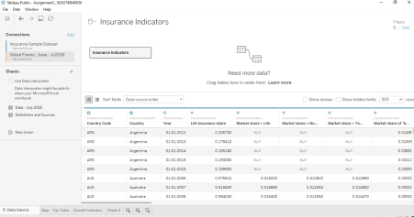

* Go to Sheet one and rename it as MAP.
* To Create a MAP, drag Country from Insurance Sample Dataset and put on Detail Mark card and then go to automatic and click map. Then drag Income from Global Financial Development Database to filter and select all and click on show filter. Drag Income to Colour Mark Card and Country Code to text Mark card.

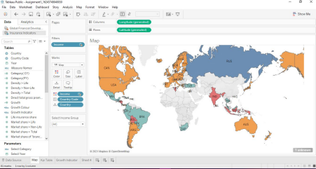

* Create 2 Parameters , One for Select Year and Another Select Category.
* To create Parameters go to the Down key below the Filter button in the Data panel, And click on Create Parameter. For Year parameter click on Date data type and for Select Category Click on String Data type.

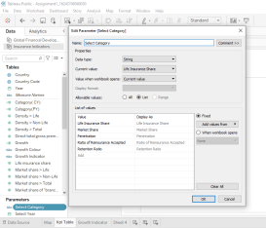

* Create Calculated Field: To Select
* Category, Categorial CY(Current year) and Categorial PY(Previous Year),Growth %.
* Click on Analysis Pane , and then Calculated Field and do calculations for the
* Following:

Select Category is for : to Select Category Parameter

* Categorial CY: Selected Period Value

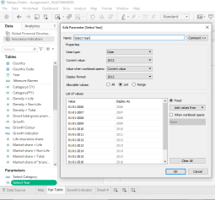

Categorial PY : Comparison Period Value

* Growth : For Growth %

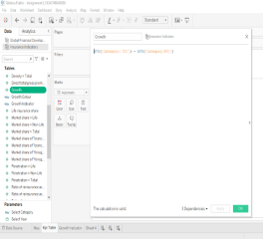

* Create a KPI Calculator: Go to new sheet and rename it KPI table and click on Sheet title and insert
* Select Category
* Click on Parameters and Show Parameters.

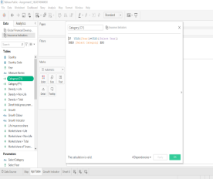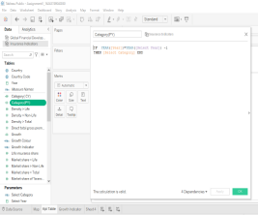

* Drag Measure Names to Row and filter it to Categorical CY , Categorial PY , Growth. And Measure Values to Text Mark card

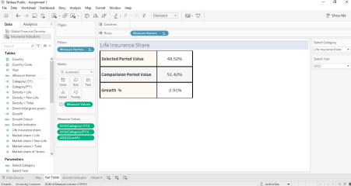

* To create a growth indicator:
* Create 2 Calculated Field: Growth Colour and Growth Indicator:

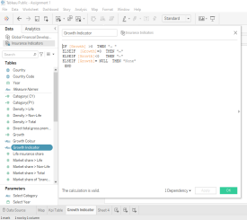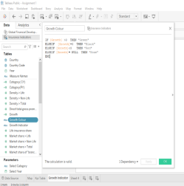

* Growth Indicator Visualization : Go to New Sheet and rename it Growth Indicator
* Click on Parameters and Show Parameters.
* Drag Growth Colour to Colour and Growth Indicator To text.

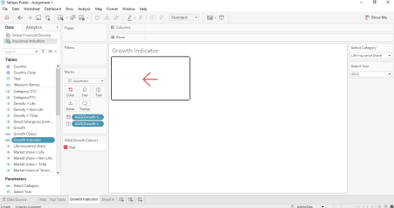

* To Create Trend Chart: Go to New sheet and rename it Trend Chart. Click on Parameters and Show Parameters.
* Drag Year to Columns and Select Category Measure to Rows.
* Year to Pages [To make a Motion Chart] and click on Show history and Trails.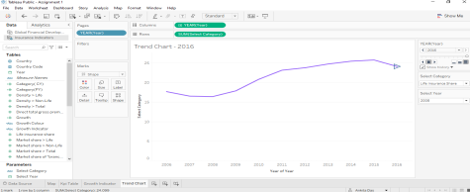
* Create a Dashboard: Click on Dashboard button .
* Go to Size and click Automatic.
* Go to Objects and click on Horizontal, Then Vertical , and then Horizontal, Drag Map to sheet , From Objects drag web Page to sheet.
* Then Go to Dashboard , Click Action -> add action -> go to URL -> edit action-> Source sheet -> Map and Run action -> Select
* And add the URL in URL bar.

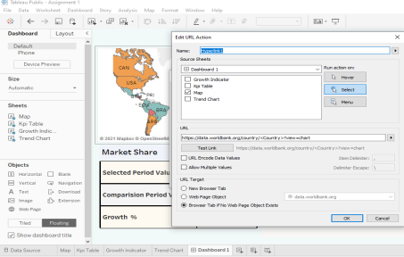

* Go to Object , the drag Horizontal Tab again.
* Click on Floating -> add KPI sheet, Growth Indicator sheet and Trend Chart sheet and rearrange it.
* Then click on Select Income Filter -> More options -> Apply to Worksheets -> Selected worksheet -> click on All on Dashboard.
* Then click on Dashboard -> click on actions -> add action -> filter-> edit filter -> source sheet -> KPI table
* Target sheet-> All except KPI table
* Run on action -> Click on Select.

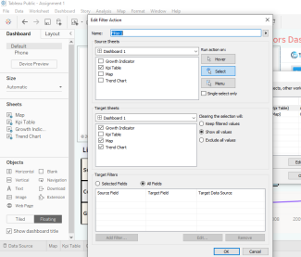

* Dashboard ready to slideshow.

